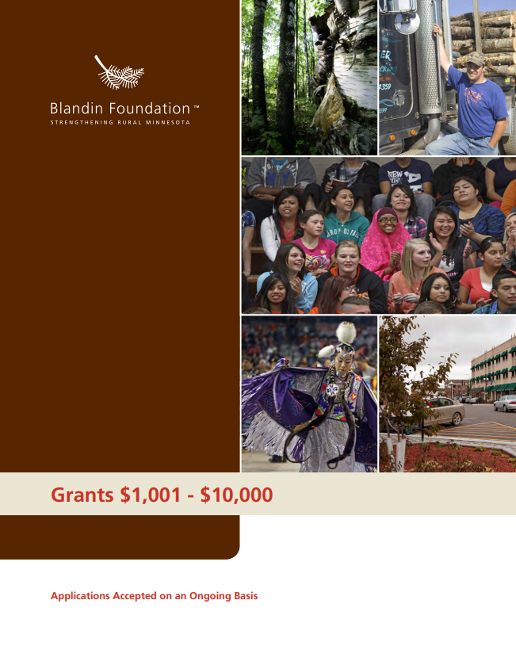

Grants $1,001 to $10,000
If you haven’t already, please visit our website to check your project’s fit with our eligibility guidelines and areas of focus. Please email all grant applications to grants@blandinfoundation.org. Supporting information may be mailed separately or scanned and sent as attachments. If you do not receive acknowledgment of your application in 2-3 business days, please call us at 218-326-0523.

Organization Information
______________________________________ ______________________________________
Name of organization Name on articles of incorporation, if different _________________________ __________________________ ________________________________
Address City, State, Zip Employer Identification Number (EIN)
__________________________ __________________________ _______________________________
Phone Fax Website
_________________________________ ___________________ _____________ ___________________

Name of Executive Director, CEO, Title Phone E-mail
Board Chair, or Lead Organizer

_________________________________ ___________________ _____________ ___________________
Name of contact person regarding Title Phone E-mail
this application

Is your organization an IRS 501(c)(3) nonprofit? ☐ Yes ☐ No
If no, is your organization a public agency, tribal government entity, or unit of government?
☐ Yes ☐ No
If no, list name and address of fiscal agent, including EIN number: ___________________________________________ ________________________________
EIN Number

If working through a fiscal agent, please attach an email or letter confirming they have agreed to be fiscal agent for your organization.

Proposal Summary
Duration of project: ____________________________ to ______________________________
Please give a 2-3 sentence summary of your proposal:

Please give a 1-2 sentence summary of the geographic area your proposal will serve:

Please give a 1-2 sentence summary of how your board and staff are representative of the population you serve.

Budget Summary
Fiscal Year of Organization or Project: ____________________ to ______________________
Total project budget: $
Total dollar amount requested of Blandin Foundation: $
Total annual budget (organization, division, or program): $

Signature
_____________________________________________________________________________________ Name of CEO/Executive Director or Board Chair
_____________________________________________________________________________________Signature (scanned/electronic signature acceptable)

Proposal Narrative
Note About Writing
Please follow the outline below as you prepare your proposal narrative. Take the space needed to tell your story, but try to be concise in your answers. We care about our personal relationship with you more than a written relationship and recognize that many organizations don’t have professional grant writers on staff. Don’t worry. A brief, thoughtful application with good rationales and easily understandable data will be reviewed similarly to a long, elaborate application. However, you help yourself and us by writing succinctly. If you have questions, don’t hesitate to call or email.

I. Explain the project

II. Project goals

III. Project budget

IV. Optional attachments (if not provided above):
Please don’t feel obligated to provide any attachments. If you can provide the project budget detail in the question above, feel free to do so. A staff member will contact you if additional information is needed.

Please submit your application to grants@blandinfoundation.org

