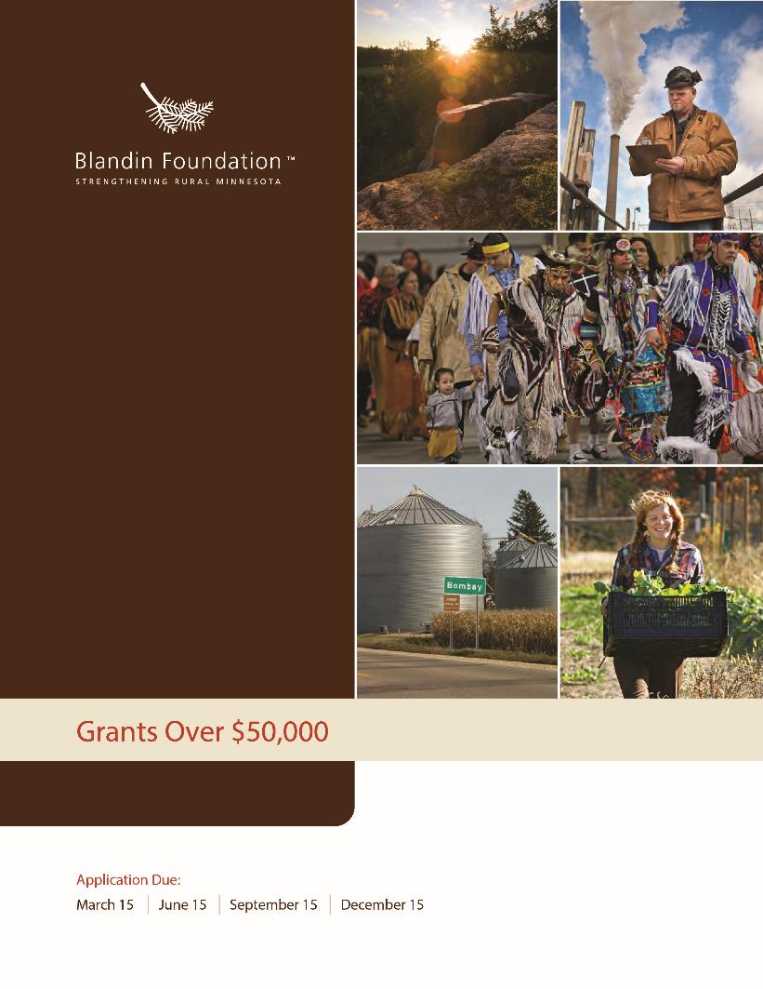

Grants Over $50,000
If you haven’t already, please visit our website to check your project’s fit with our eligibility guidelines and areas of focus. Please email all grant applications to grants@blandinfoundation.org. Supporting information may be mailed separately or scanned and sent as attachments. If you do not receive acknowledgment of your application in 2-3 business days, please call us at 218-326-0523.

Organization Information
______________________________________ ______________________________________
Name of organization Name on articles of incorporation, if different _________________________ __________________________ ________________________________
Address City, State, Zip Employer Identification Number (EIN)
__________________________ __________________________ _______________________________
Phone Fax Website
_________________________________ ___________________ _____________ ___________________

Name of Executive Director, CEO, Title Phone E-mail
Board Chair, or Lead Organizer

_________________________________ ___________________ _____________ ___________________
Name of contact person regarding Title Phone E-mail
this application

Is your organization an IRS 501(c)(3) nonprofit? ☐ Yes ☐ No
If no, is your organization a public agency, tribal government entity, or unit of government?
☐ Yes ☐ No
If no, list name and address of fiscal agent, including EIN number: ___________________________________________ ________________________________
EIN Number

If working through a fiscal agent, please attach an email or letter confirming they have agreed to be fiscal agent for your organization.

Proposal Summary
Duration of project: ____________________________ to ______________________________
Please give a 2-3 sentence summary of your proposal:
Please give a 1-2 sentence summary of the geographic area your proposal will serve:
Please give a 1-2 sentence summary of how your board and staff are representative of the population you serve.

Budget Summary
Fiscal Year of Organization or Project: ____________________ to ______________________
Total project budget: $
Total dollar amount requested of Blandin Foundation: $
Total annual budget (organization, division, or program): $

Signature
_____________________________________________________________________________________ Name of CEO/Executive Director or Board Chair
_____________________________________________________________________________________Signature (scanned/electronic signature acceptable)

Proposal Narrative
Note About Writing
Please follow the outline below as you prepare your proposal narrative. Take the space needed to tell your story, but try to be concise in your answers. We care about our personal relationship with you more than a written relationship and recognize that many organizations don’t have professional grant writers on staff. Don’t worry. A brief, thoughtful application with good rationales and easily understandable data will be reviewed similarly to a long, elaborate application. However, you help yourself and us by writing succinctly. If you have questions, don’t hesitate to call or email.

I. Organizational Profile (3-4 Pages, Less Is Fine For Requests Under $50,000)
- Provide a brief summary of organization history, mission or purpose, programming/activities, and recent accomplishments.
- Tell us about your staff and board.
  - How many staff and board members does your organization have?
  - If the makeup of your staff and board is not representative of the community you serve, please explain why and how you plan to address this.
- In addition to your own, what other organizations/providers serve the people and issues you care about?
- How do you partner/collaborate with others to continually strengthen your own work and serve people and communities better?

II. Purpose Of Grant (5-7 Pages, Less Is Fine For Requests Under $50,000)
A. Background
1. Describe the opportunity your proposal addresses.
- Help us understand the context, reach and scale of the work you are undertaking.
- You are welcome to attach a one-page diagram or chart to illustrate your proposed work (this is optional).
2. What organizations and individuals are involved in planning and implementing your proposed project/work?
- What steps are you taking to include community members who will be most impacted by your work?
B. Implementation
1. What are the specific goals of your project? Please be concise, a short list is optimal.
2. What are the intended outcomes of the project? In other words, what will be different when your project/program is successful?
3. What strategies and/or activities will be employed to achieve these outcomes? Please reflect on how your proposed work is a good fit with Blandin’s priorities.
4. Tell us about your project leadership.
- Is the organization equipped to handle what you are proposing; will you have to hire new staff?
- Please share any other organizational implications related to carrying out this work (ex: new partnerships, signed agreements, physical relocation).
5. No project is without obstacles. Realistically, what are some of the challenges your proposed work/project will face?
6. What are your short term or long-term strategies for sustaining this effort?

III. Assessment (1-2 Pages)
A. Explain how you will measure/document the progress that is being made toward the goals and outcomes you have identified above.

IV. Budget (1 Page, In Addition To Attaching Your Budget(s))
A. Describe the amount and type of resources that will be needed to see this project through, and steps you are taking to mobilize the necessary resources.
1. Additional funders. List names of corporations, foundations or individuals from whom you seek funds. Include amounts and whether sources are committed or pending.
B. Submit a copy of your organization budget.
C. Submit a copy of your project budget (if a form is helpful, click here).
1. Please include in the project budget all sources of income as well as major expense categories. Remember to include non-cash or in-kind donations.
2. Feel free to attach a narrative explaining your numbers, if necessary.

V. Attachments
A. Most recent financial statements (audited, if available), including balance sheet, statement of activities (or statement of income and expenses) and functional expenses.
B. List of board members and their affiliations (or paste a link to your website here, if the information is current).

Proposal Checklist
A complete grant application consists of the following:
☐ Completed, signed proposal summary form (the first two pages of this application)
☐ Proposal narrative
☐ Organization budget
☐ Project budget (n/a if you have been invited to submit a proposal for operations funding)
☐ Audited financial statements, if available
☐ List of board members (or link to website)

Please submit your application to grants@blandinfoundation.org

